The first line graph we can see is number of games released per year. From the graph we can easily see number of games released per year is increased over the year as gaming industry is vastly developing and people have easier access to computers and gaming console. In this graph we have not added 2023 as we have database only till mid of 2023 due to which we had a big drop in number of games released in 2023.

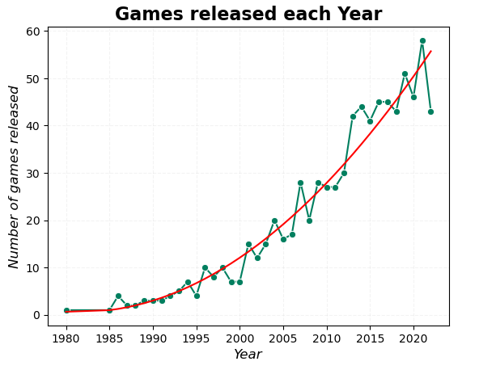

In the second line graph we can see number of games released per month. We have three seasons of game release one in March which may be due to spring break, second peak in June which may be due to summer vacation. And third season In September October and November where people start to shop for holidays like thanksgiving and Xmas. which causes increased number of games released with biggest peak in November.

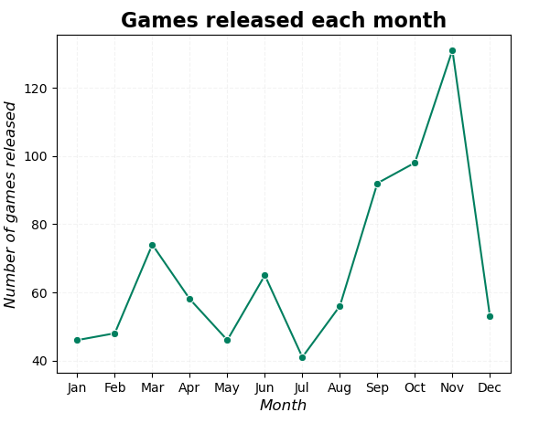

In next bar chart we can see top 20 games plays vs playing where green indicates plays and yellow playing. First game the legends of Zelda: tears of kingdom which released in May 2023 highest number of plays due to repeatability also it was the most recent game released in our database. It is a successor of top 3rd game the legends of Zelda: breath of the wild which was released in March 2017. The 2nd game Minecraft which is released November 2011 still have high number of players as it has different modes to offer to its player.

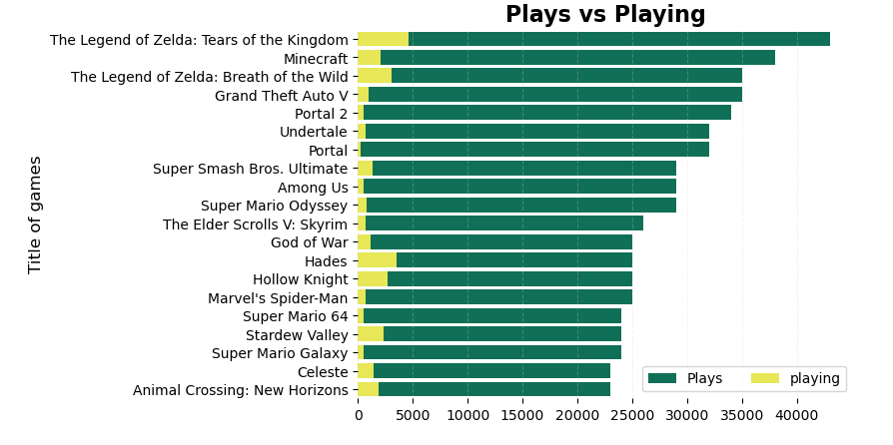

In next chart we can see top 20 games and number of platforms it is released. Some games are released on 1 platform and some games are released on 9 platforms. From this chart we can easily see number of platforms and top games does not have any relation. Which concludes to become a top game, number of platforms it is released on does not matter.

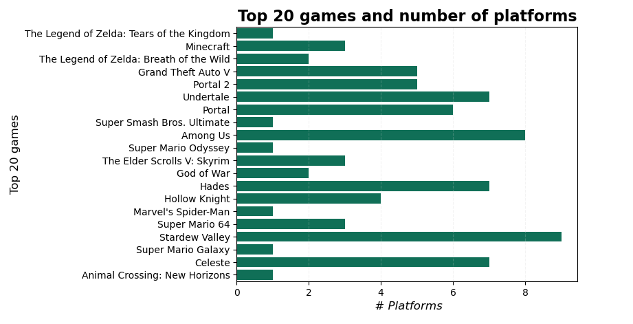

Bias and limitation

We need more details on user base and concurrent player. Also, game type is not mentioned whether the game is liner live or limited. Our data base is static and not updated with API. Data set was last updated in mid-2023 so it may not be accurate in today’s date. Also, the origin of data is unknown. We need more documentation on source of data.